Makor Oven System

Substrate Specifications
Substrates having the following approximate maximum and minimum dimensions can be transported through the equipment offered:
Length | maximum | 6500 mm | (256")
 | minimum | 305 mm | (12")
Width | maximum | 1300 mm | (51")
 | minimum | 50 mm | (2")
Thickness | maximum | 50 mm | (2")
 | minimum | 10 mm | (3/8")

Scope Of Delivery
- Timed Belt Conveyor, Makor Model ROLLY 3500/T
- Multilevel Oven System, Makor Model MULTILEVEL 7000/6

Item 1

Timed Belt Conveyor

Makor Model ROLLY 3500/T
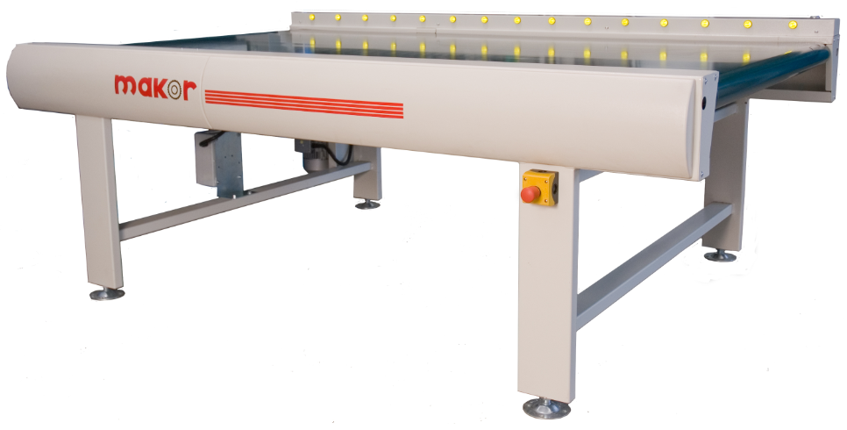

Timed Belt Conveyor
- belt conveyor to use as an infeed conveyor for the system
- utilized for the manual loading process
- designed to create groups or charges for loading into multilevel oven
- transport system is located inside a solid steel structure
- synthetic transport belt is resistant to abrasion and chemical agents
- forward feed is adjustable by inverter

Options Included
- equipped for timed/charge formation
- one (1) independent control panel mounted on conveyor

Technical Specifications
overall dimensions | 3500 x 1600 x 900 mm | (138 x 63 x 35-1/2")
max. working width | 1300 mm | (51")
working height ± 50 mm | 900 mm | (35-1/2")
feed speed ± 5% | 2 to 10 m/min | (6.6 to 32.8 ft/min)

Utility Requirements
Electrical
operating voltage | 480 V/3-phase/60 Hz
total connected load | 0.55 kW
Electrical equipment installed according to UL regulations. Voltage supplied must not fluctuate in excess of +/- 5% of its stated value.

Item 2

Multilevel Oven System

Makor Model MULTILEVEL 7000/6
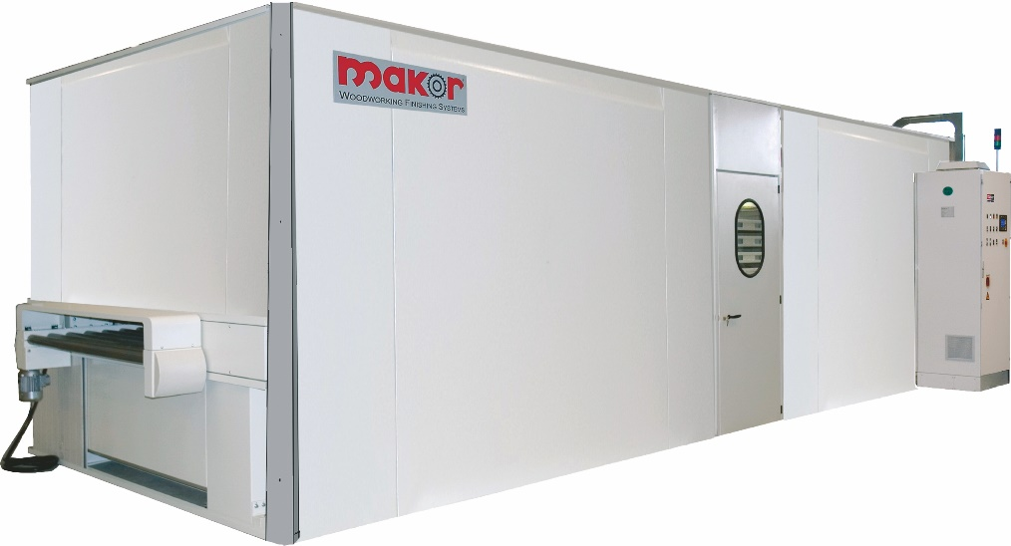

The MULTILEVEL oven allows the flash off of water-based or solvent-based coating materials. Each tray has its own independent transport belt to assure the best cleaning of the flash off zones. This is extremely important to achieve a perfect finishing quality.

The PLC manages the machine, and allows selecting the number of stages with which the operator wants to work to achieve maximum flexibility in choosing the drying time.

Structure
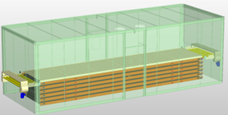
- the structure is made of sturdy painted steel profiles and is completely insulated with panels, with sliding doors for entry into the machine
- inside the insulated chamber are located the belt stages to store the pieces
- all of the trays are movable vertically and horizontally and can be positioned, alternatively and independently, to the line working stage
- the geared transmission unit automatically synchronizes with the line transport system to load pieces coming from the previous machines and then off-load pieces that have already been flashed off
- vibration-free vertical movement of the trays is achieved using a screw system
- the value control system provides perfect positioning of the stage column

Air Flow Management
- flash off zone is equipped with one fan for intake of hot air and an exhaust fan that removes the vapors released during the flash off phase
- recycling filters are located on the air intake system
- the air is heated by steam
Options Included
- automatic temperature control
- a sensor detects the air temperature inside the oven and automatically optimizes the heat exchanger that warms up the air
- this system allows using the maximum potential of the heating system when the machine is started up and saving energy once the set temperature is reached
- prepared for operation with steam
- equipped with two-meter outfeed roller element to assist with the manual unloading process

Technical Specifications
overall dimensions | 8700x3000x2650mm | (343 x 118 x 104")
max. working dimensions | 6500x1300x 50mm | (255 x 51 x 2")
feed speed | 2 to 10 m/min | (6.6 to 32.8 ft/min)
working height ±50 mm | 900 mm | (35-1/2")
number of trays | 6
tray length | 7000 mm | (275-1/2")
maximum load each tray | 120 kg | (265 lb)
feed motor power | 0.55 kW
roller conveyor motor power x2 | 0.25 kW each
tray motor power | 4 kW
intake motor power | 3 kW
exhaust motor power | 3 kW
control side | right hand

Utility Requirements
Electrical
operating voltage | 480 V/3-phase/60 Hz
total connected load | 12.0 kW
Air
exhaust air volume | 6,000 m³/hr | (3,532 cfm)
air make up required | 6,000 m³/hr | (3,532 cfm)
Heat Source
thermal power | 40,000 kcal/h | (160,000 BTU)
Electrical equipment installed according to UL regulations. Voltage supplied must not fluctuate in excess of +/- 5% of its stated value.

